modified Grid Connect (mGC)

Normal (data) message
: <S | X> <IDENTIFIER> <N> <DATA-0> <DATA-1> … <DATA-7>;
where:
':' and ';' are message start and end characters respectivel
Identifier and data fields are treated as base-16 digits (hexadecimal).
'S' & 'X' characters indicates standard or extended CAN frames
'N' character indicates a normal (not RTR) message

Request to Transmit' (RTR) message
: <S | X> <IDENTIFIER> <R> <LENGTH>;
where:
':' and ';' are message start and end characters respectively
Identifier field is treated as base-16 digits (hexadecimal)
'S' & 'X' characters indicates standard or extended CAN frames
'R' character indicates an RTR message
Length field is a single ASCII decimal character from ‘0’ to ‘8’ that specifies the length of the message

Modifications
The identifier field is modified to use a fixed length, zero padded format, and modified bit positions as follows

Standard identifier field
For a standard can message with an 11-bit identifier, the identifier field is always 4 hex characters, i.e. 16 bits
The bit positions reflect the SID0 to SID10 bits in the SIDH & SIDL ECAN registers
IDENTIFIER[0,1] - bits [11:3] of the can identifier
IDENTIFIER[2] - bits [2:0] of the can identifier, left shifted by 1
IDENTIFIER[3] – always 0
i.e. the ASCII identifier is effectively the 11-bits, shifted left 5 positions, with the lower 5 bits always 0
(EXIDE is always 0 for an 11-bit identifier, EID17 & EID16 are unused)
SIDH  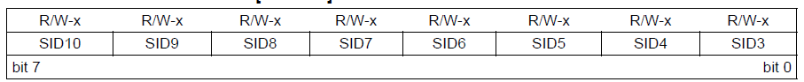 | SIDL

Extended identifier field
For an extended can message with a 29-bit identifier, the identifier field is always 8 hex characters, i.e. 32 bits
EXIDE is always 1 for a 29-bit identifier
For a 29-bit identifier (EID28:0), the bits SID<10:0> become EID<28:18>
In this case of a 29-bit identifier, the mapping is a bit more complex
IDENTIFIER[0,1] - bits [28:21] of the can identifier
IDENTIFIER[2] - bits [20:18] of the can identifier, left shifted by 1, bottom bit set to zero
IDENTIFIER[3] - bits [17:16] of the can identifier are the bottom two bits, top bit set to 1 (EXIDE)
IDENTIFIER[4,5,6,7] - bits [15:0] of the can identifier
SIDH | SIDL

EIDH  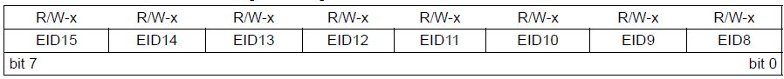 | EIDL

